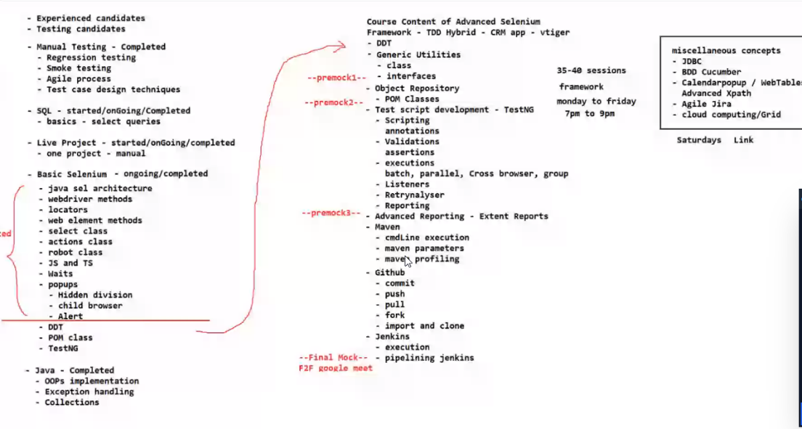

Cloud Version

https://demo.vtiger.com/vtigercrm/index.php

java: manually we have to add jars and its tedious to d on daily basis if new jars are generated

Maven: offer folder structure

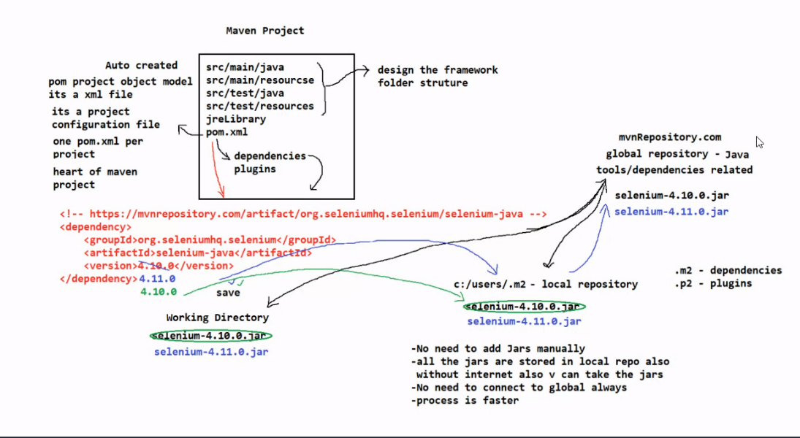

Maven: Plugin available in Eclipse

Provides dependendencies which are available in the maven repository

Copy the dependencies and place it in pom.xml and save it

Maven will connect to global repo and search for the 4.11.0 jars

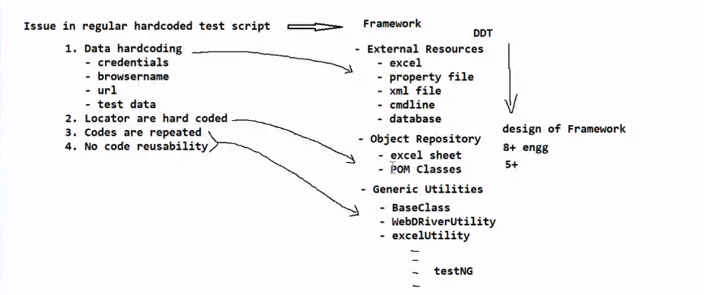

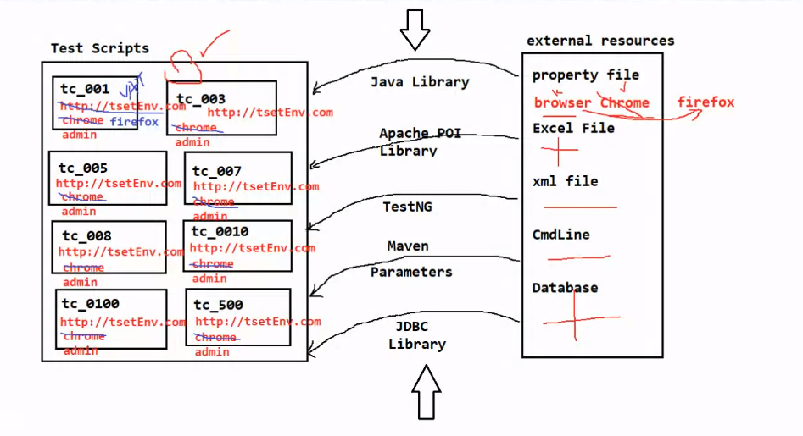

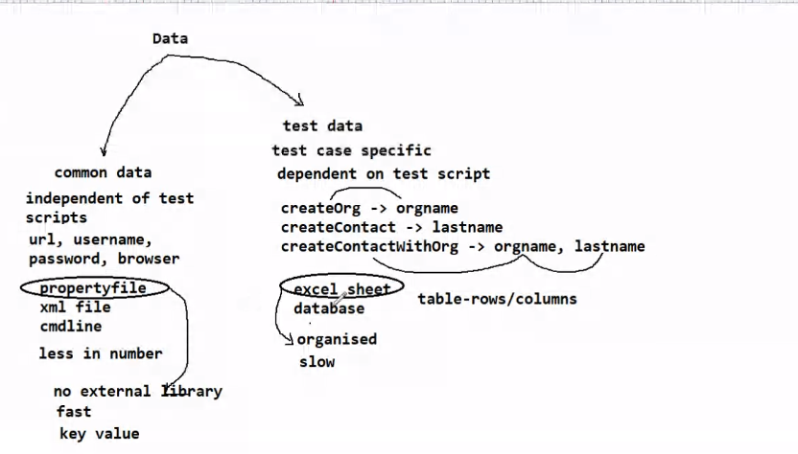

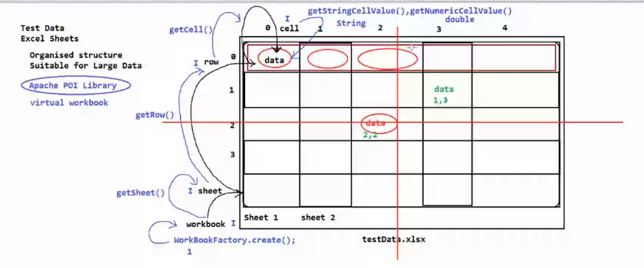

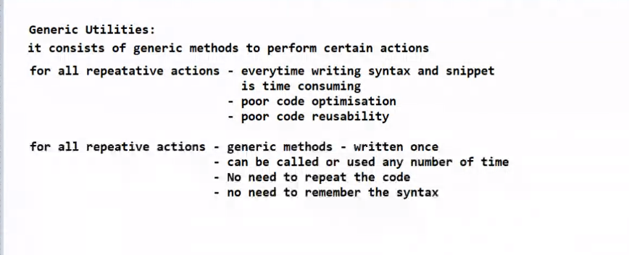

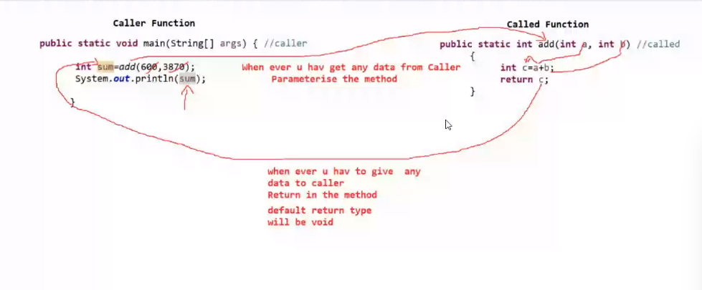

No main method in----generic utility—src/main/java

/** enter---description

For easy access we use non-static method

POM

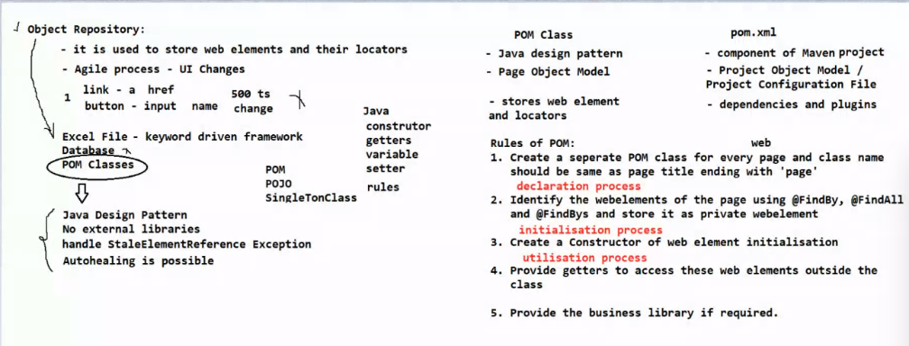

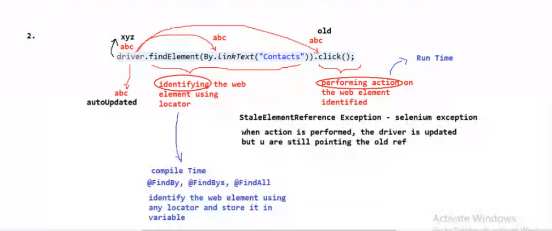

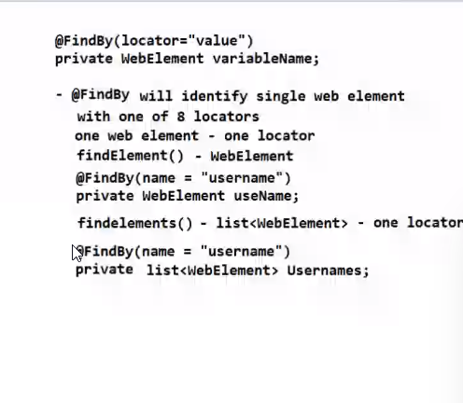

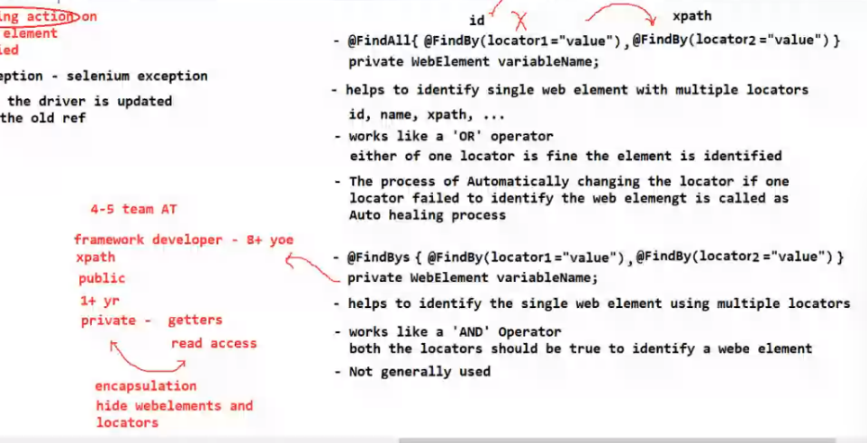

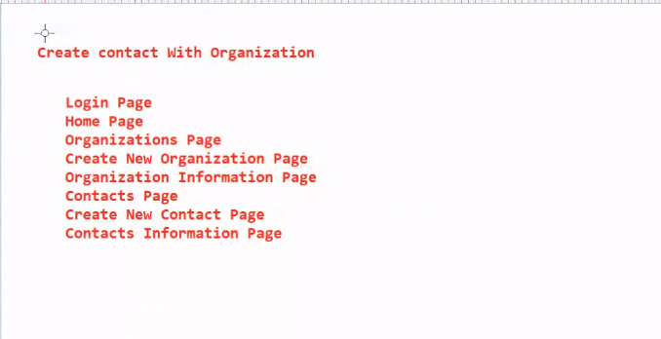

Limitation POM:

Using @findBy we can not write dynamic xpath

**TestNG**

If its available: Right click🡪build path🡪configure build path🡪Add libraries🡪select TestNG🡪next🡪apply and close

Install TestNG

Help🡪Market place🡪

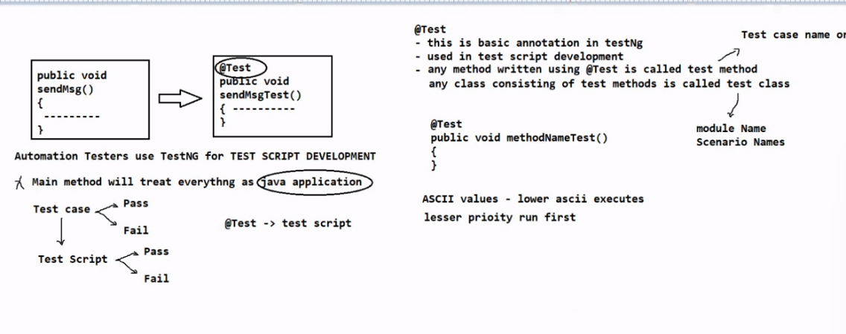

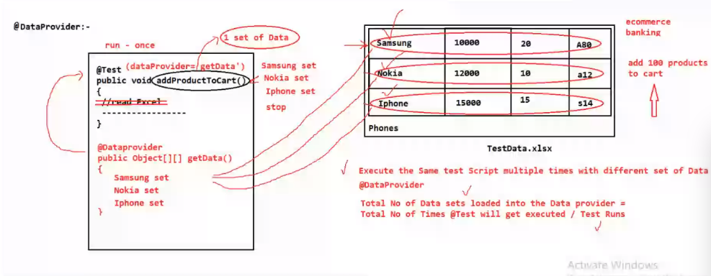

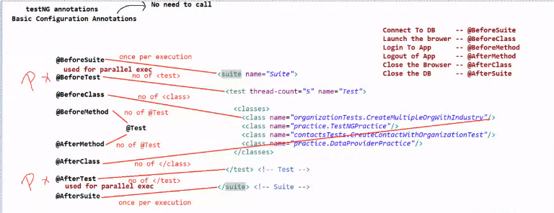

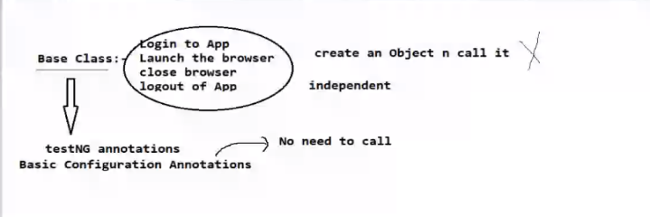

Assertion

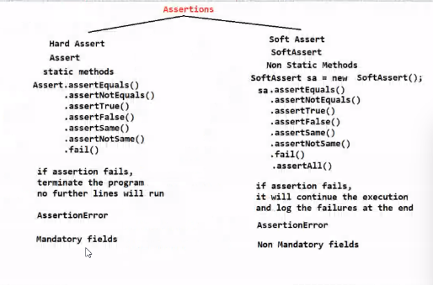

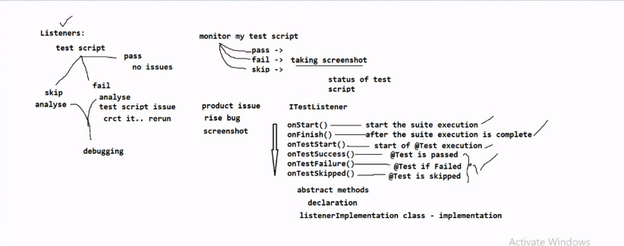

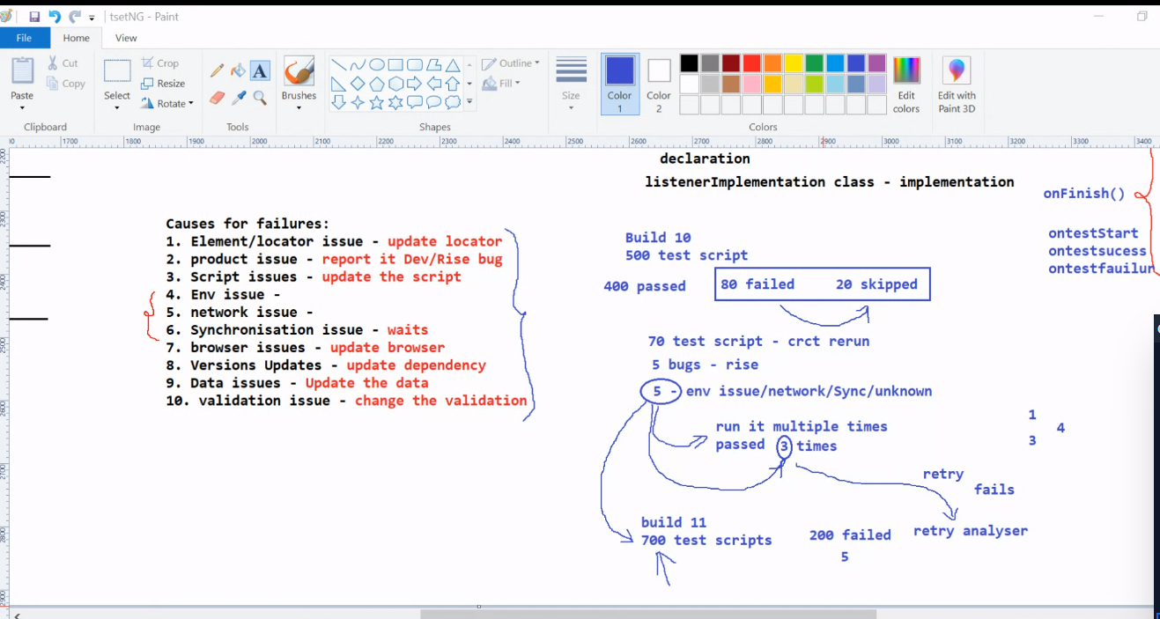

Maven

Maven -version

Go to pom path🡪select🡪type cmd

Mvn clean

Mvn validate

Mvn test(mvn -Dtest=classname test)

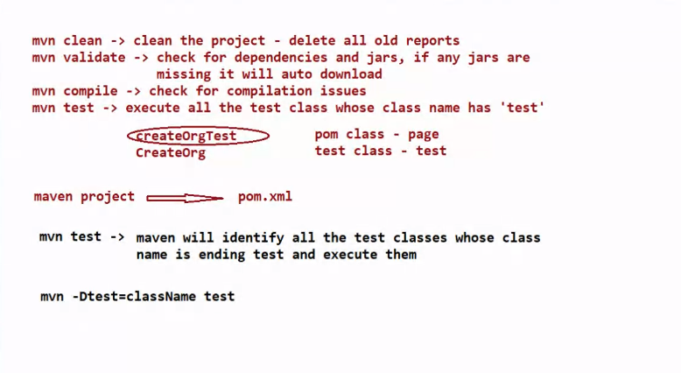

Exceptions:

org.testng.internal.reflect.MethodMatcherException: when the passing parameter datatype and formal argument datatype are no matching